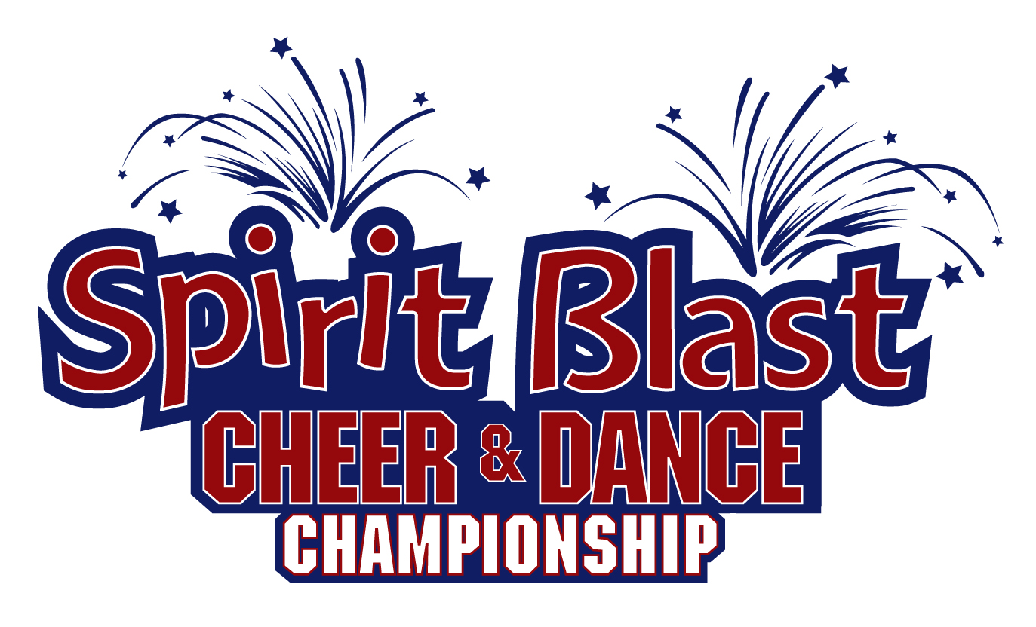

CLASSIC REGISTRATION FORM

We look forward to seeing you at SPIRIT BLAST Cheer & Dance Championship!
We encourage you to promptly return the needed information to reserve your place at this year’s SPIRIT BLAST competition. We will need the following information:
team registration information and deposit.

Registration Information

Team Name:
Contact Person:
Phone: Fax: E-mail address:
Mailing Address:
City: State: Zip:
Division: Level:
Competition Date: Competition Location:

Payment Information

Total # of Nationals Competitors: x $45.00 = $
Total # of Multi-Division competitors: x $35.00 = $
Total # of Individual / Stunt groups: x $35.00 = $

Total Deposit Enclosed: $ Total Registration: $

**A $5.00 per person discount is offered to all teams registering for a second competition**

- A minimum deposit of $20 per person must accompany the registration form to proceed
- Remaining balance due 30 days prior to the scheduled competition
- Please send one check or money order payment per organization - individual checks will not be processed
- Please make checks payable to: SPIRIT BLAST, LLC
- Checks returned due to insufficient funds will be subject to a $30 NSF charge
- Please send registration information and payment to: SPIRIT BLAST
3213 Tolmas Dr
Metairie, LA 70002
- Upon receipt of registration forms and deposit, a confirmation letter will be e-mailed to the contact person listed above. Please contact us with any questions: 1-504/733-7811

Cancellation and Refunds Policy
There are no refunds on deposits for any reason. For a refund (less all deposits) a notice of cancellation must be received in writing at the SPIRIT BLAST office no less than 30 days prior to the scheduled competition.

I have read, understand and agree to the Cancellation and Refunds Policy stated above.

Sponsor Signature Date

Thank you for competing at SPIRIT BLAST Nationals!

